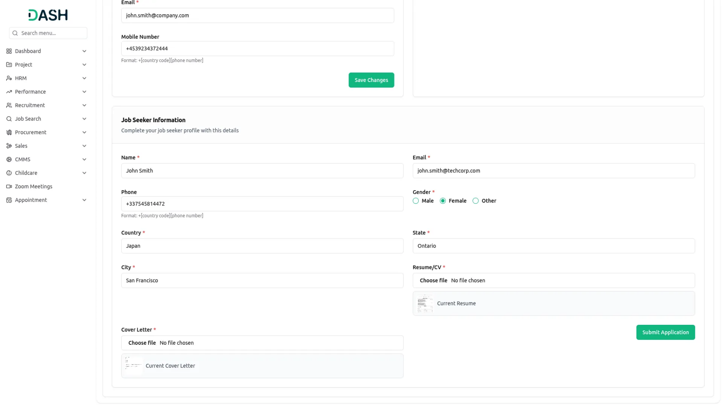

Simplified Job Searching
The Job Search Integration simplifies the process of posting job openings. Recruiters can easily create and publish job listings on multiple platforms with just a few clicks. This integration allows for customizable job descriptions, requirements, and application forms, ensuring that each job posting is detailed and specific to the role. By automating and centralizing job postings, businesses can reach a wider audience and attract more qualified candidates.

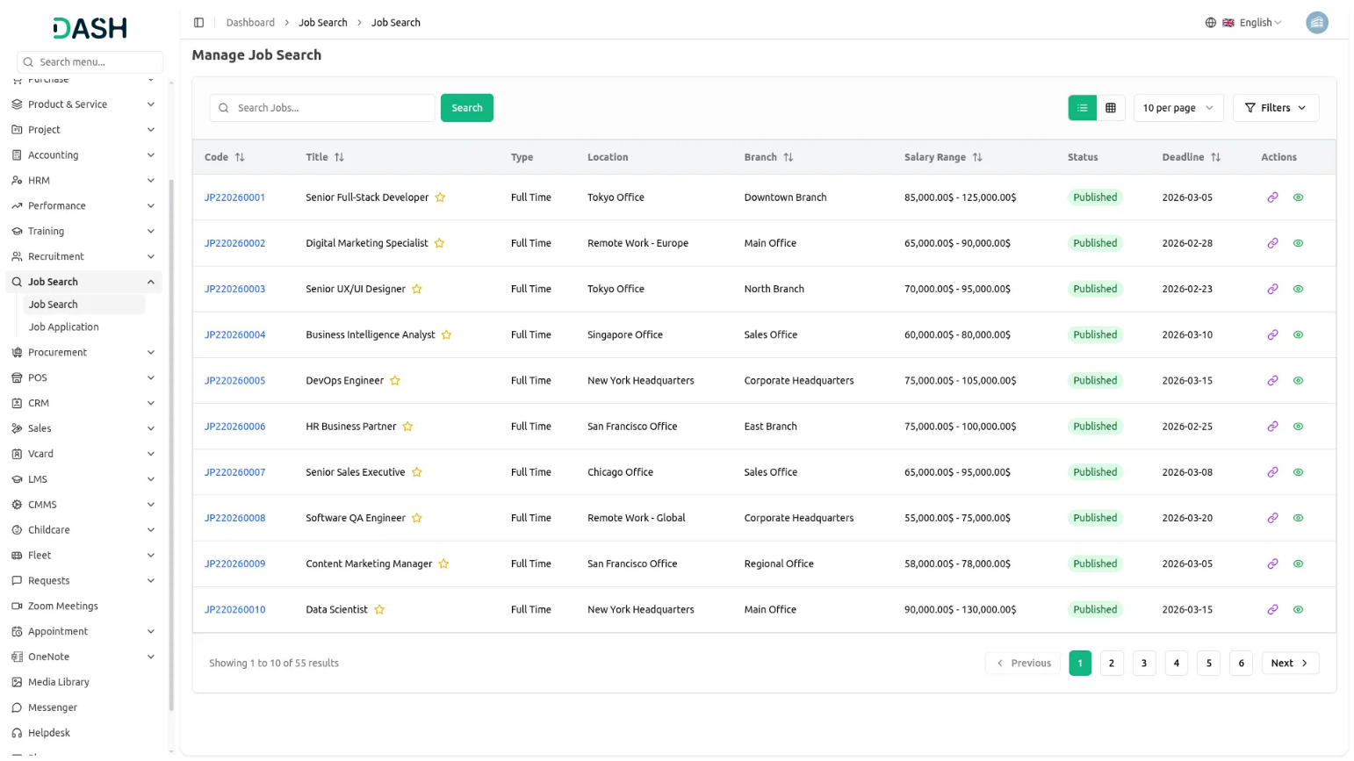

Efficient Application Tracking
Tracking job applications is crucial for a successful recruitment process, and the Job Search Integration excels in this area. Recruiters can manage and monitor all incoming applications from a single dashboard, making it easy to keep track of each candidate’s progress. The integration provides tools for sorting, filtering, and rating applicants, ensuring that the most suitable candidates are easily identified. This organized approach helps maintain a smooth and efficient hiring process.

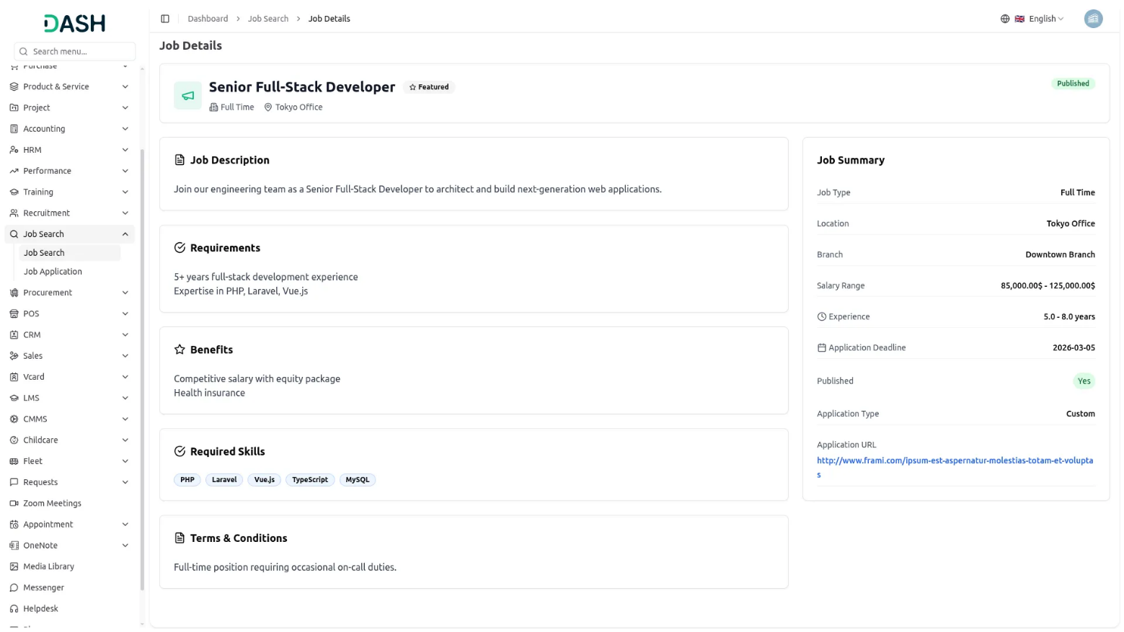
Improved Candidate Communication
Effective communication with candidates is essential, and the Job Search Integration in Dash SaaS enhances this aspect significantly. Recruiters can communicate with applicants through integrated messaging tools, ensuring timely updates and responses. The integration also includes features for scheduling interviews and meetings, complete with automated reminders and calendar sync options. This streamlined communication process improves the candidate experience and ensures that all parties stay informed and engaged.

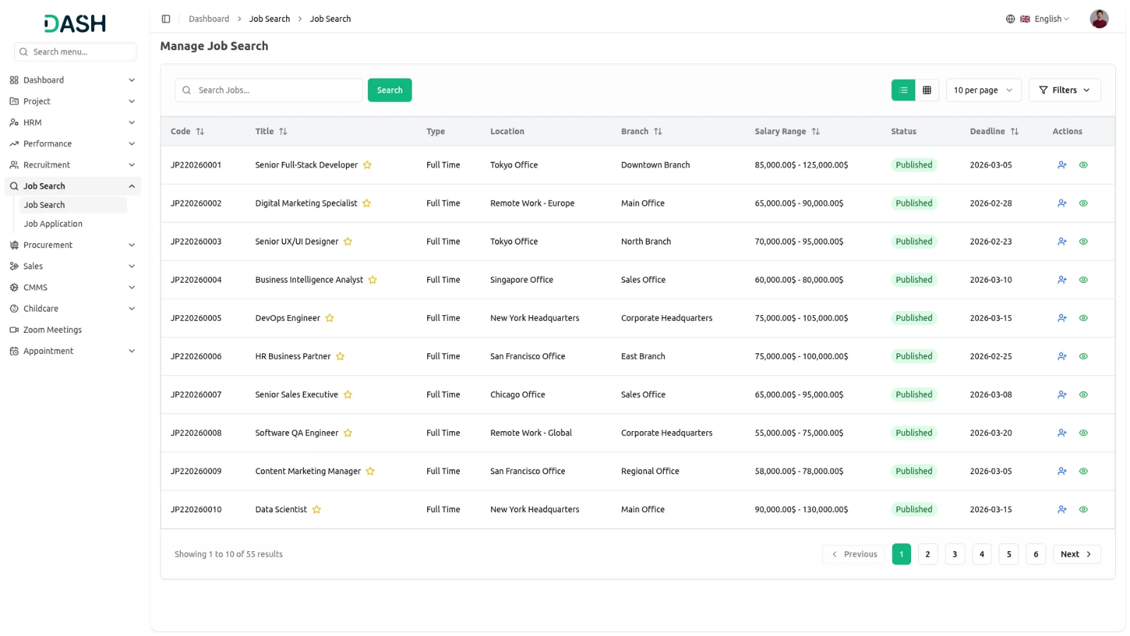

Data-Driven Recruitment Insights
The Job Search Integration offers valuable insights and analytics to help businesses refine their recruitment strategies. Detailed reports on job posting performance, applicant sources, and hiring timelines provide recruiters with the data needed to make informed decisions. By analyzing these metrics, businesses can identify trends, optimize their recruitment processes, and enhance their overall hiring effectiveness. Data-driven insights ensure that recruitment efforts are strategic and result-oriented.

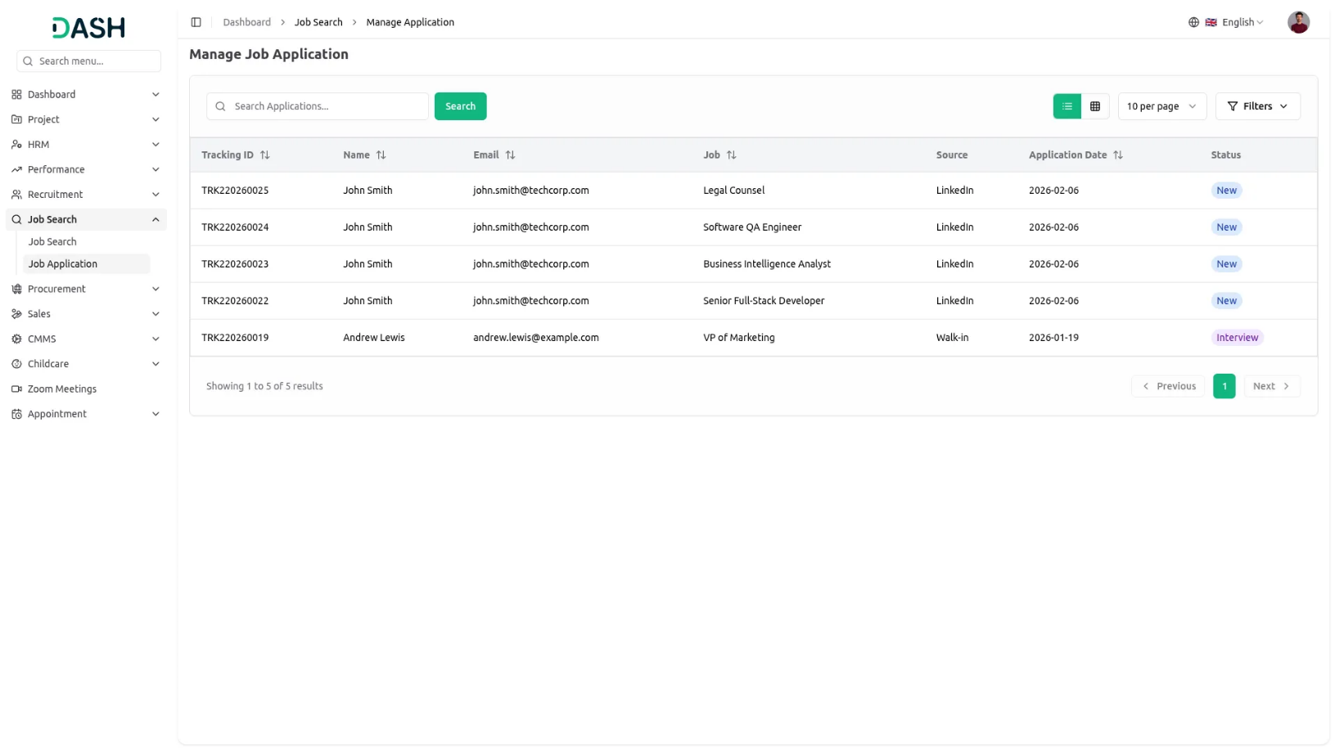
Introduction
The Job Search Add-On enables organizations to manage job postings and applications through an integrated recruitment system. This Add-On depends on the Recruitment Add-On and allows administrators to view and manage job listings, track applications through different stages, and monitor candidate progress. Staff members can configure their job seeker profiles and apply for available positions directly through the platform. The system provides comprehensive tracking from job posting to application management with detailed filtering and reporting capabilities.
Note: This Add-On is dependent on the Recruitment Add-On, so you need to purchase it first.
How to Use the Job Search Add-On?
Company Login – Manage Job Search
- The Job Search Add-On depends on the Recruitment Add-On and will only function when the Recruitment Add-On is active. All job data comes from the Manage Job Add-On within the Recruitment system.
- To view available jobs, use the filter options at the top of the page including Job type, Location, Department, Status fields. Click “Apply” to activate your filters or “Reset” to clear all filter selections. You can also use the Search button to find specific jobs or Export button to download job listings data.
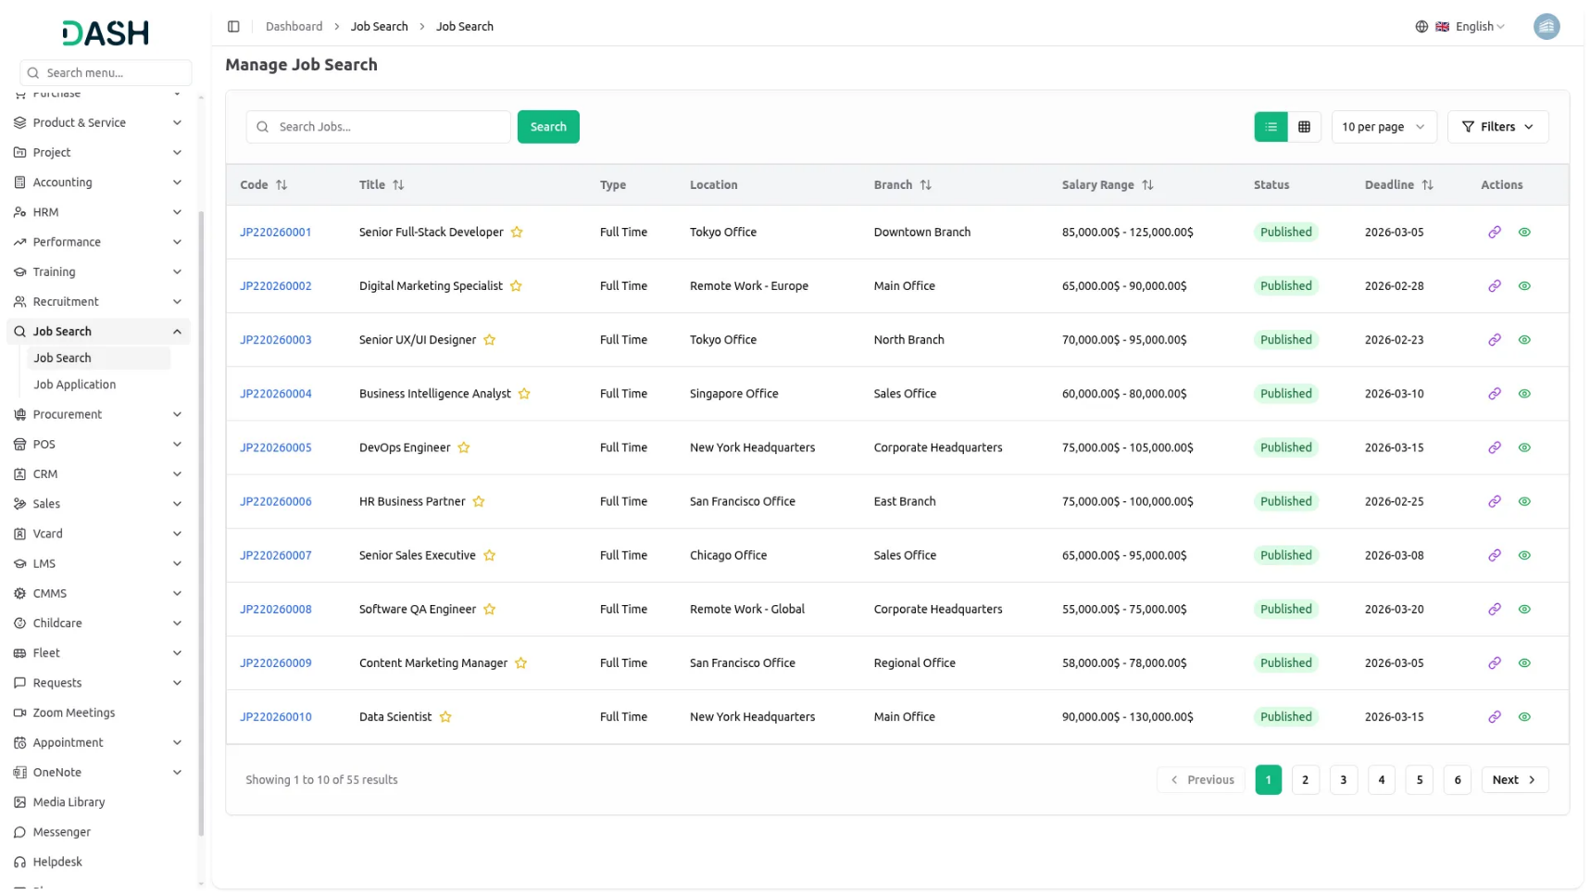
- The list page displays all job postings in a table format with columns for Code, Title, Type, Location, Department, Salary Range, Status, and Deadline. In the Actions column, you can Copy job postings after the job status is set to post, or click View to access comprehensive job details.

- When you click View in the Actions column, a detailed page opens showing Job Details, Job Status, Job Description, Job Requirements, Benefits, Required Skills, Terms & Conditions, Job Summary and Requisition.
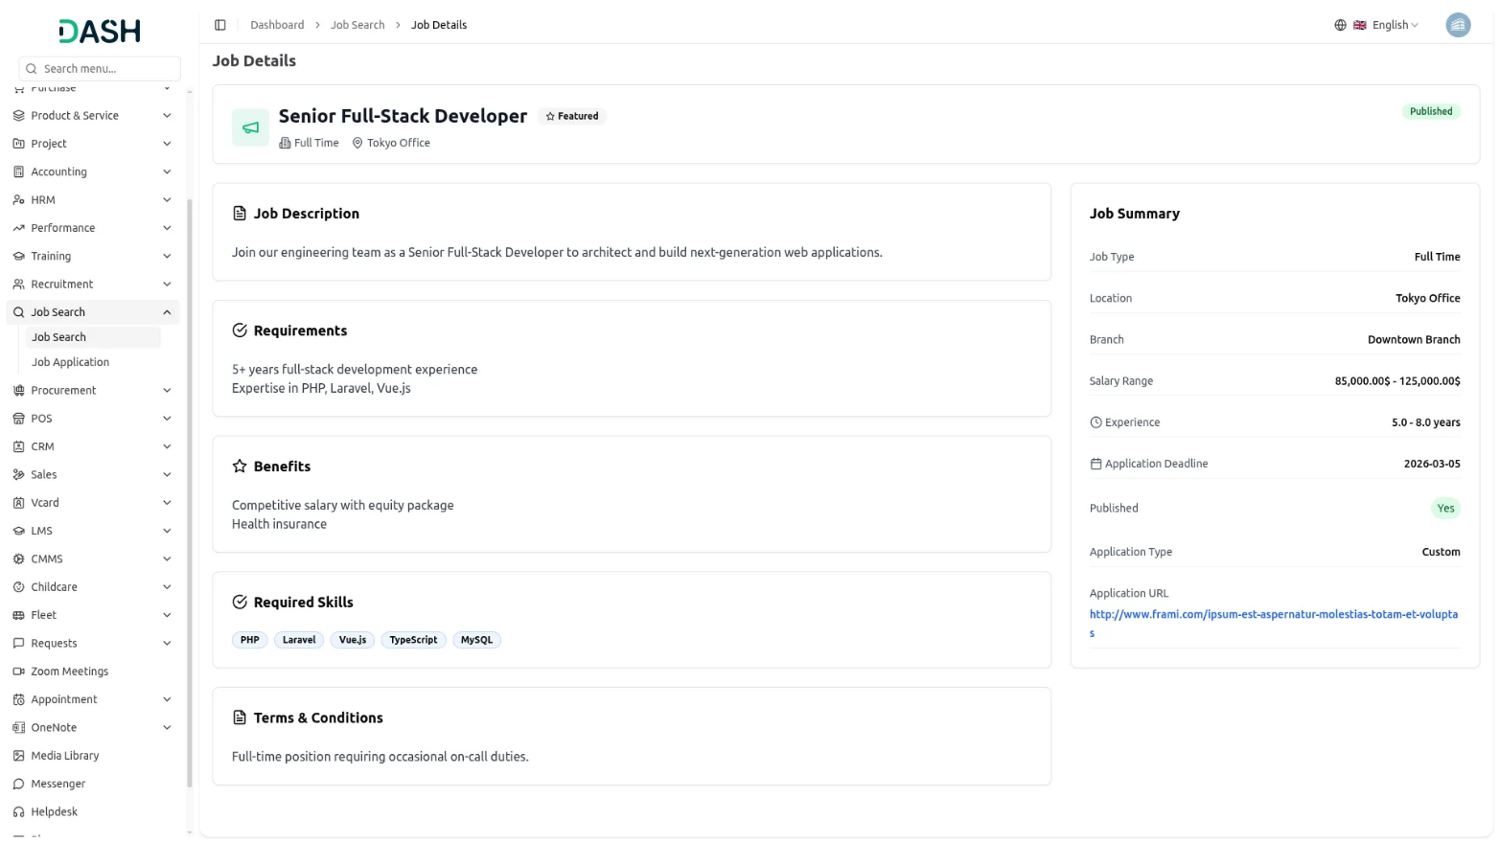

Company Login – Manage Job Applications
- To manage job applications, access the applications Add-On where you can filter by Job selections from the recruitment job posting Add-On, and Status options from the job stage Add-On in recruitment and Application Date. Use Apply to activate filters or Reset to clear selections.
- Click the “List View” button to switch to a GridView format that displays applications in a table with columns for Tracking ID, Name, Email, Job, Source, and Application Date.
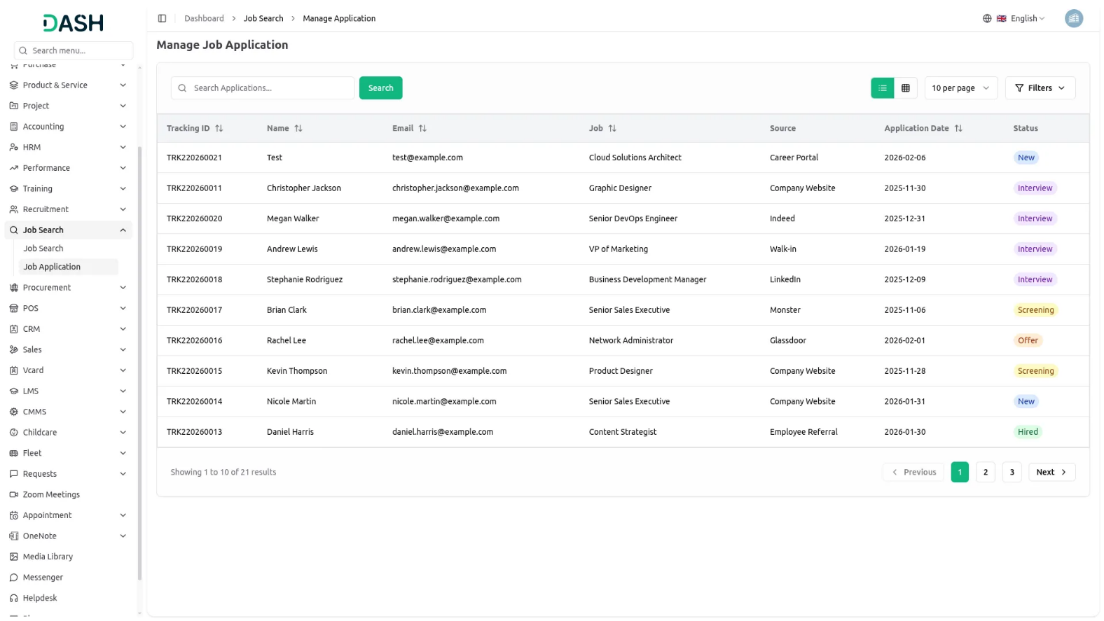

Staff Login – Job Seeker Configuration
- Before applying for jobs, staff members must configure their job seeker profile. Navigate to Edit Profile then Job Seeker Information to access the configuration page.
- Fill out your personal information including Name, Email, Phone, and select your Gender from Male or Female options. Enter your location details by specifying Country, State, and City. Upload your Resume/CV and Cover Letter to complete your professional profile.
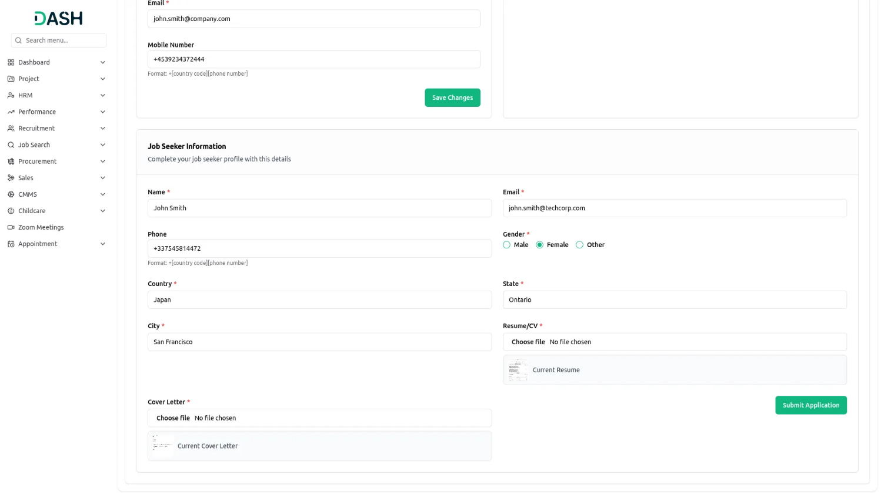
- This job seeker information will be automatically used when applying for jobs through the job search Add-On, though you can modify details during the application process if needed.

Staff Login- Manage Job Search
- Once your job seeker profile is configured, you can browse and apply for available positions. Access the job search section to view all posted job opportunities.
- Use the filter options to narrow your search by Job type, Location, Department, and Status then click Apply to activate filters or Reset to clear them. The Search helps you find specific positions or save job listings for reference.
- The job listings appear in a table showing Code, Title, Type, Location, Department, Salary Range, Status, and Deadline information. In the Actions column, click Apply to submit your application for any job.
- When you click View in the Actions column, a detailed page opens showing Job Details, Job Status, Job Description, Job Requirements, Benefits, Required Skills, Terms & Conditions, Job Summary and Requisition.
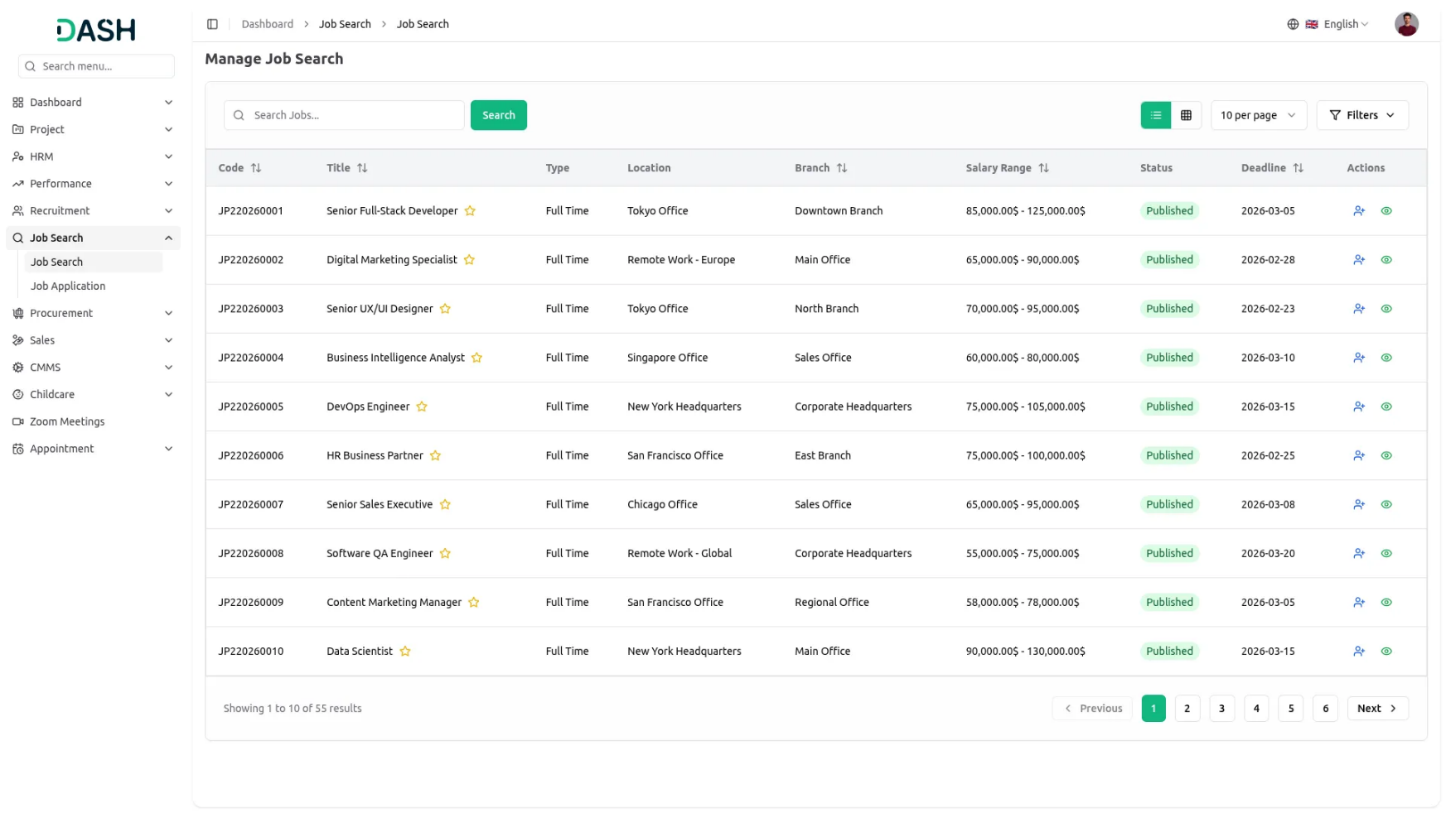
- When you click Apply, the system automatically fills in your information from the job seeker profile section, but you can modify any details before submitting your application.
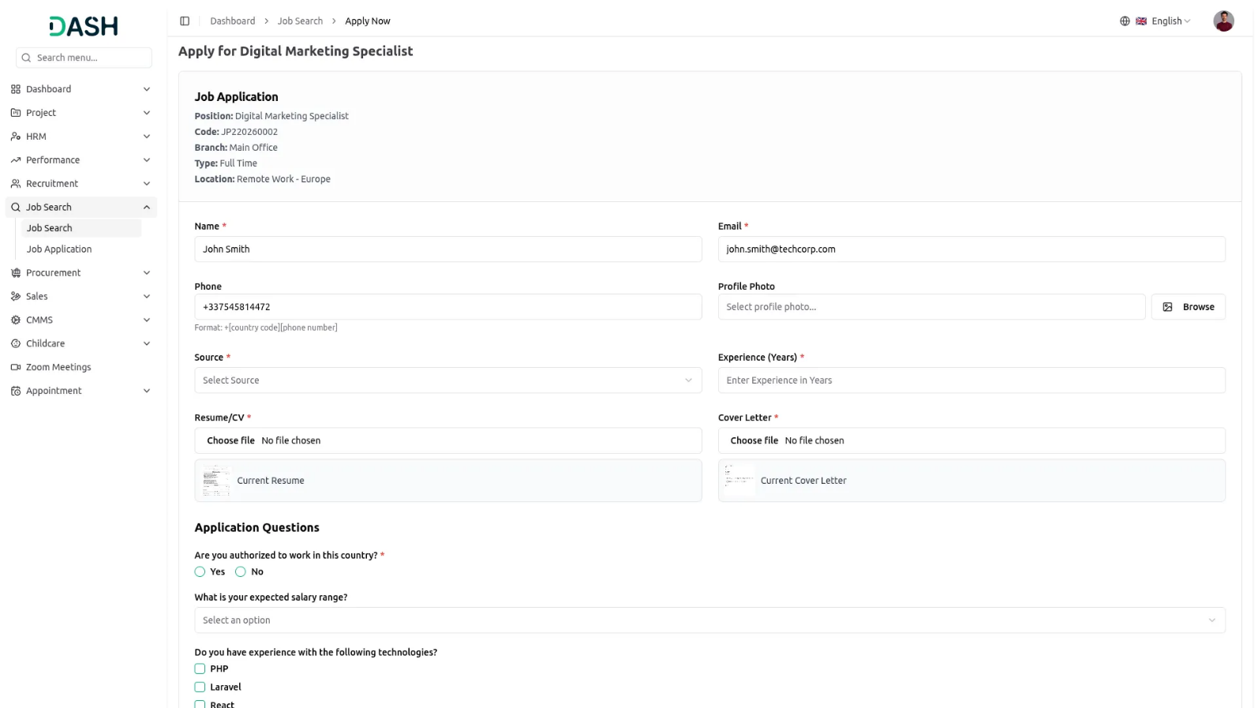

Staff Login – Manage Job Applications
- After applying for positions, you can track your applications through the application management section. Use filters for Job selections from the recruitment Add-On, and Stage options from the job stage Add-On to find specific applications and Application Date.
- Click the “List View” button to switch to a GridView format that displays applications in a table with columns for Tracking ID, Name, Email, Job, Source, and Application Date.

